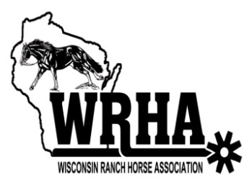
Wisconsin Ranch Horse Association
Year End Awards

Exhibitor must be a current year WRHA member and must show at a minimum of three of the four WRHA shows to qualify for any of the following awards.

Class Awards:
Awards given to 1st, 2nd & 3rd highest point earners in each class. Must earn at least one point in the class to receive the award. Class points will be tabulated based on the following table. Points will be awarded based on class placings and any points earned in a Grand or Reserve halter class.
# Horses | Placings
In Class | 1st | 2nd | 3rd | 4th | 5th | 6th | 7th | 8th | 9th | 10th
1 | 0
2 | 2 | 1
3 | 3 | 2 | 1
4 | 4 | 3 | 2 | 1
5 | 5 | 4 | 3 | 2 | 1
6 | 6 | 5 | 4 | 3 | 2 | 1
7 | 7 | 6 | 5 | 4 | 3 | 2 | 1
8 | 8 | 7 | 6 | 5 | 4 | 3 | 2 | 1
9 | 9 | 8 | 7 | 6 | 5 | 4 | 3 | 2 | 1
10 & Over | 10 | 9 | 8 | 7 | 6 | 5 | 4 | 3 | 2 | 1

In the case of a tie, the exhibitor/horse with the highest number of points earned in that class under Judge A at the four WRHA shows will be the winner.

Division High Point Awards:
Awards given to 1st, 2nd & 3rd highest point earners in each Division.
All Age Division
Amateur Division
Novice Amateur Division
Youth Division
Green as Grass Division

Points earned will be determined using the points schedule above. Final points total will include all points earned by the horse in the All Age Division and by the exhibitor/horse combination in Amateur, Novice Amateur, Youth and Green as Grass divisions at the WRHA shows. To qualify, exhibitor must have shown in at least one cattle class in that division at each of the shows for points from that show to count towards the respective award.

In the case of a tie, the exhibitor/horse with the highest number of points earned in that class under Judge A at the four WRHA shows will be the winner.

Top Cow Horse Award:
Awards given to the highest total point earners in all cattle classes for the All Age and Amateur division.
In the case of a tie, the exhibitor/horse with the highest number of points earned in that class under Judge A at the four WRHA shows will be the winner.

